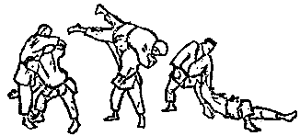

ANNUAL KATA FESTIVAL

- Observe some of the nine judo kata being performed
- Demonstrate a kata and get expert feedback
- Join us for lunch

Date: Sunday, March 26, 2017
Time: 11:00 AM to 1:00 PM, with lunch afterwards
Location: Pembroke Hill School
300 Belanger Drive, Pembroke, NH
Cost: Demonstrators & spectators / $10.00 per person or family

* check www.nhjudo.org for updates

Directions
----------------
From the south:
Take I-93 north to exit 9N.
Turn right at the end of the exit (north on Rt. 3).
Go through the outskirts of Manchester, through Suncook
and into Pembroke (about 10 miles).
One mile after the Pembroke traffic light, turn right at the
next traffic light onto Pembroke Hill Road.
At the top go right. Take the next right.
Go down the hill and you will see a parking lot.
Go to the gym, which is to the left as you enter the building.
From the north:
Take I-93 south to exit 13. Turn left at the end of the exit.
Follow Rt. 3 south towards Pembroke for about 4 miles.
Turn left at the traffic light onto Pembroke Hill Road.
At the top go right. Take the next right.
Go down the hill and you will see a parking lot.
Go to the gym, which is to the left as you enter the building.
Contact Jim Miller if you want to demonstrate a kata or have any questions:
Email: sankawajudo@cs.com
Cell: 603-520-1880

